Smart Todo App
Application Explanation Document

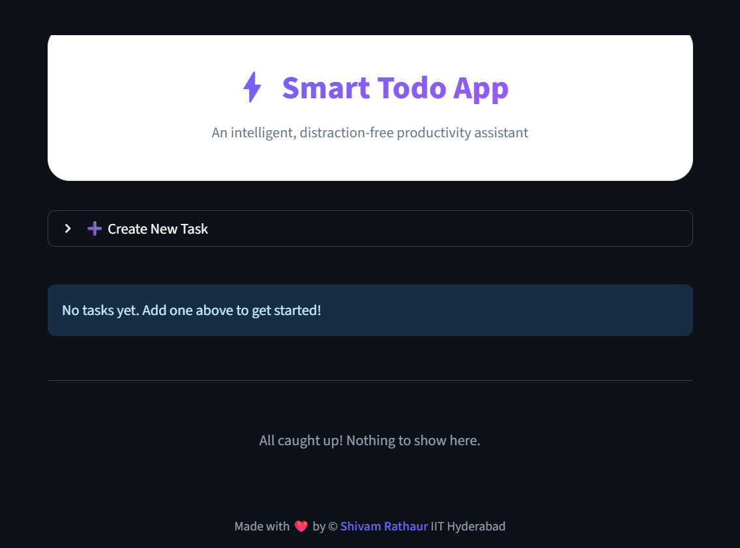

Name: Shivam Rathaur
Institute: Indian Institute of Technology Hyderabad
Technology Stack: Python, Streamlit, SQLite, Generative AI (Gemini API)
Introduction
This document explains the design, functionality, and implementation of the Smart Todo App.
The objective of this application is to provide a clean, user-friendly task management system enhanced with Generative AI to assist users in overcoming task-related procrastination. The app emphasizes robustness, usability, and secure handling of external APIs.

Technology Stack & Architecture
- Technology Stack
- Python: Core application logic
- Streamlit: Frontend UI and interaction handling
- SQLite: Lightweight local database for persistent task storage
- Generative AI (Gemini API): AI-based task analysis feature
- Custom CSS: Used to enhance UI appearance and user experience
- Architecture Overview
The application follows a modular design:
- app.py
Handles UI rendering, user interaction, session state management, and integration of all components.
- database.py
Manages all SQLite operations such as creating tables, adding tasks, updating task status, editing tasks, and deleting tasks.
- ai_utils.py
Encapsulates all Generative AI logic, including secure API access through environment variables and graceful fallback handling.
This separation ensures maintainability, readability, and robustness.

Core Features
- Task Management
The application allows users to create detailed tasks with the following attributes:
- Task Title (required)
- Description (optional)
- Priority level (1 = highest, 5 = lowest)
- Due date, time and time zone support
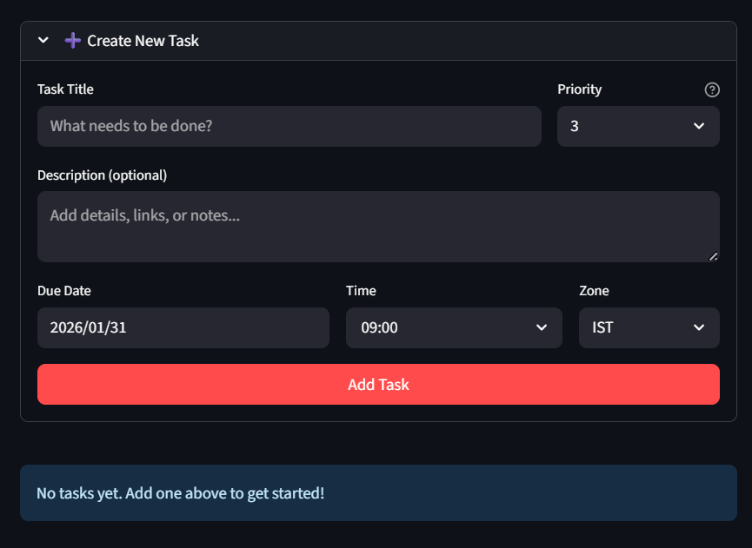
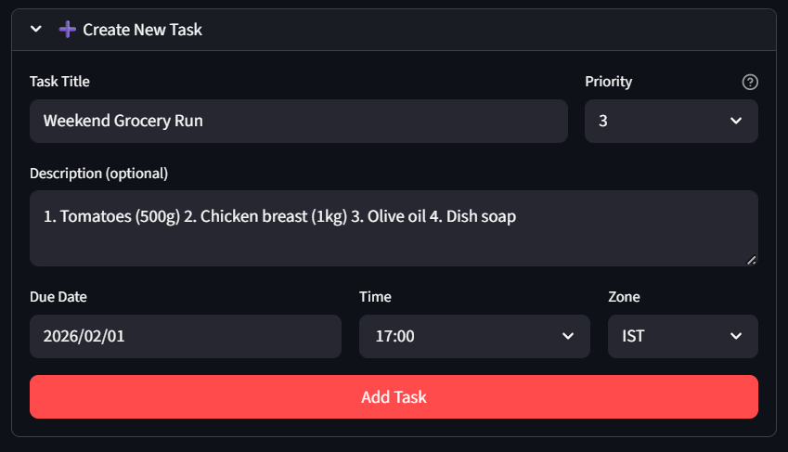

Users can:
- Edit tasks inline without leaving the main view
- Mark tasks as completed or undo completion
- Permanently delete tasks
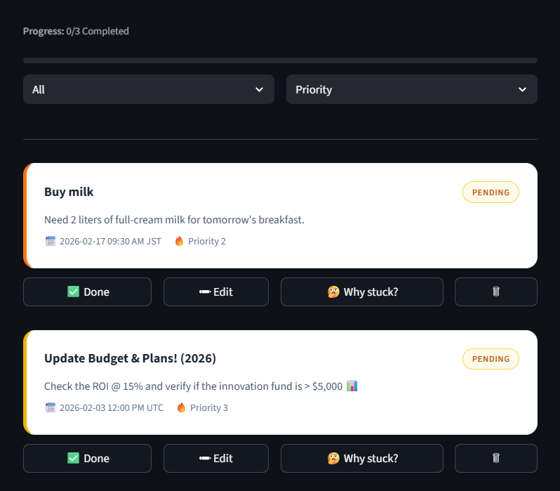

- Task Organization & Tracking
To help users stay organized, the app provides:
- Priority-based visual indicators using color-coded borders
- Sorting options by priority or due date
- Filtering options to view all, pending, or completed tasks
- Progress bar displaying overall task completion percentage
These features make it easy to track progress at a glance.

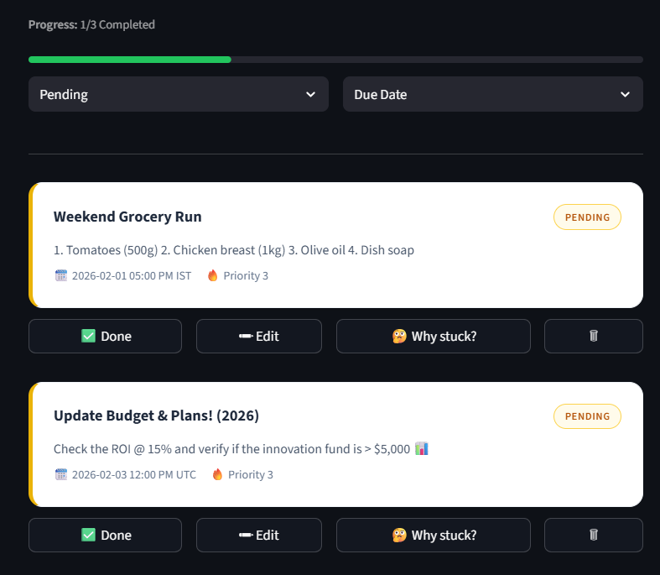
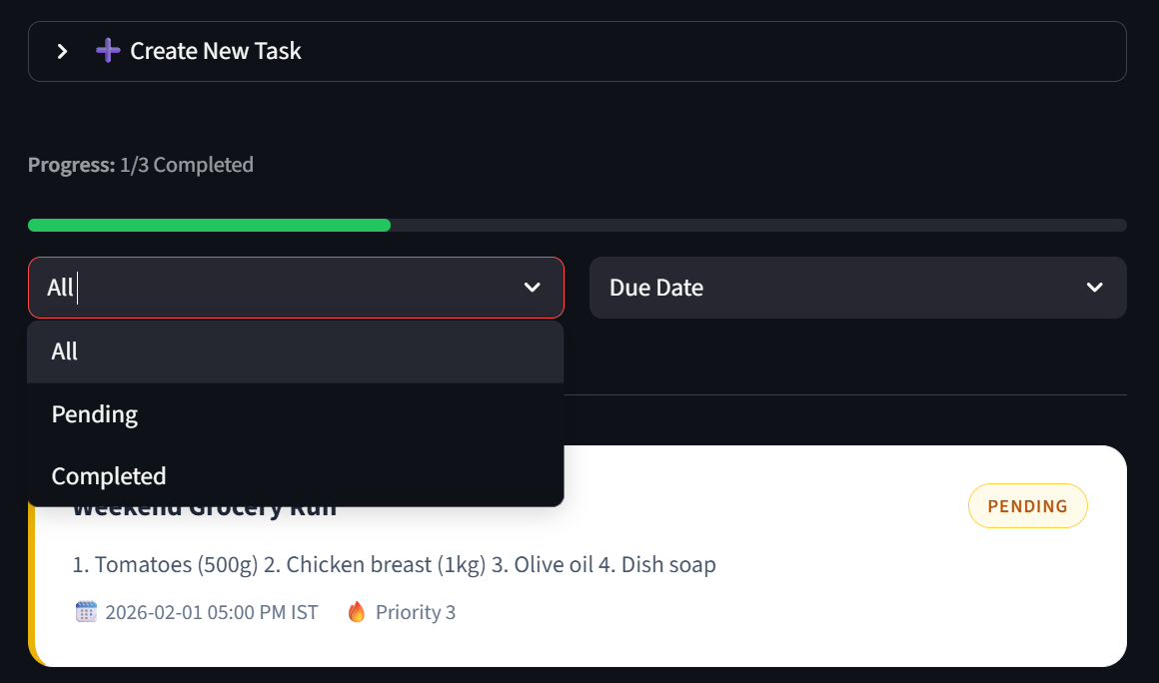

Generative AI Integration
- “Why Stuck?” Feature
The app includes a Generative AI feature designed to assist users when a task feels difficult to start.
When the user clicks “Why stuck?”, the AI:
- Analyzes the task title
- Provides a short, human-friendly explanation of why the task may feel challenging
- Suggests a small, actionable step to help the user get started
This feature is intentionally designed to be supportive rather than intrusive.
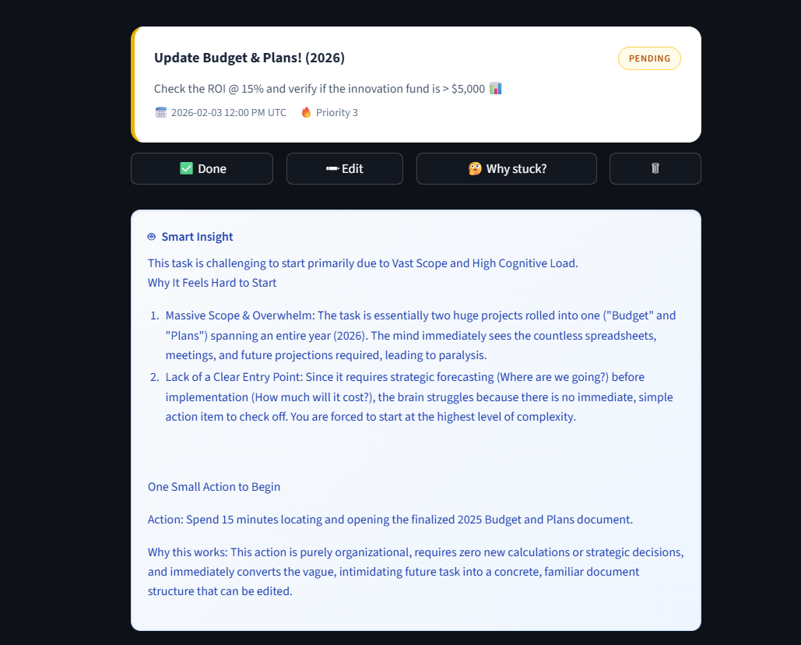

- Robust AI Error Handling
To ensure stability:
- API keys are never included in the source code
- Keys are accessed only via environment variables
- If the AI service fails (e.g., quota exceeded or network issue), the app displays a graceful fallback message instead of raw errors
This ensures the app never crashes due to external API issues.

UI / UX Design Considerations
The UI was designed with simplicity and clarity in mind:
- Modern card-based layout for tasks
- Clean typography and consistent spacing
- Hover effects for better visual feedback
- Explicit action buttons to avoid accidental submissions
- Prevention of unintended task creation via keyboard input
The design aims to balance aesthetics with usability, making the app intuitive for first-time users.
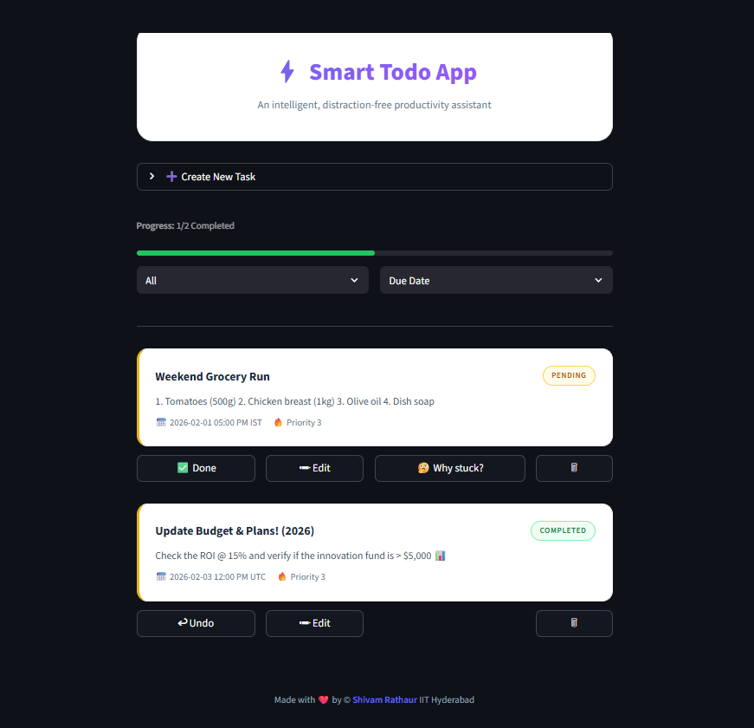
Data Persistence & Reliability
All task data is stored locally using SQLite:
- Tasks persist across application restarts
- Status, priority, due date, and edits are reliably saved
- No external database setup is required
This approach ensures both simplicity and reliability.
Security & Best Practices
- No API keys are hardcoded or committed
- Environment variables are used for sensitive credentials
- Graceful handling of API failures
- Clean session state management to avoid unintended behavior
These practices align with industry standards for secure application development.
How to Run the Application
- Install dependencies:
  - pip install -r requirements.txt
- Set the environment variable for the AI API key:
  - Windows: setx GEMINI_API_KEY "api_key"
  - macOS / Linux: export GEMINI_API_KEY="api_key"
- Run the app:
  - streamlit run app.py

Conclusion
The Smart Todo App demonstrates practical use of Python, SQLite, Streamlit, and Generative AI to build a robust, user-friendly application. The project emphasizes clean architecture, thoughtful UI design, secure API usage, and meaningful AI integration.
This application reflects both technical proficiency and attention to user experience.

GitHub Repo: Click Here

Made with ❤️ by © Shivam Rathaur IIT Hyderabad

